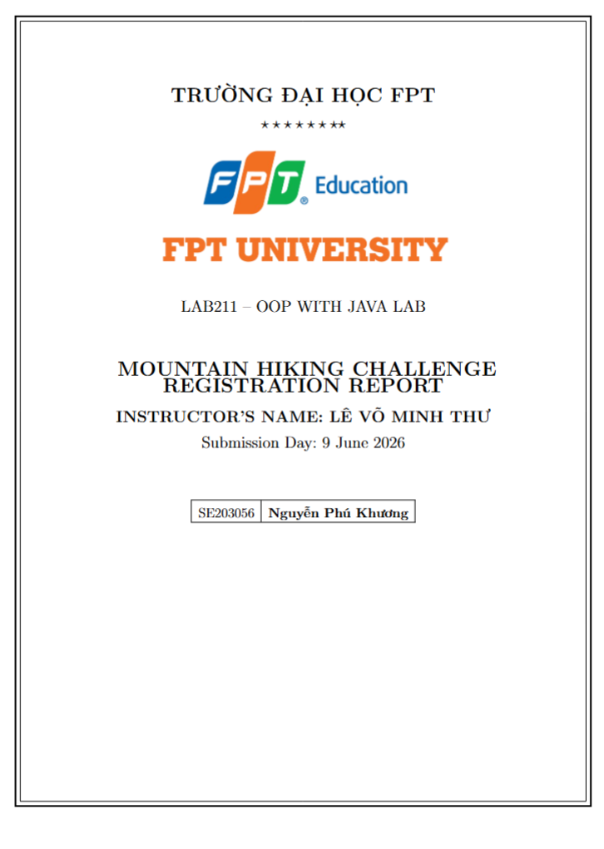

Contents
1
1. Project Introduction 5
1.1. Problem Description 5
1.2. Lab Requirements 5
1.3. Technologies Used 6
2.1. Project Structure 6
2.2. Class Diagram 6
3. Detailed Class Descriptions 9
3.1. Interface Acceptable 9
3.2. Class Inputter 9
3.3. Class Mountain 10
3.4. Class Mountains 10
3.5. Class Student 11
3.6. Class Students 12
3.7. Class StatisticalInfo 12
3.8. Class Statistics 13
3.9. Class Main 13
4. User Guide for Each Feature 14
4.1. Main Menu 14
4.2. Feature 1: New Registration 15
4.3. Feature 2: Update Registration Information 18
4.4. Feature 3: Display Registered List 19
4.5. Feature 4: Delete Registration 20
4.6. Feature 5: Search Participants 21
4.7. Feature 6: Filter by Campus 23
4.8. Feature 7: Statistics by Mountain 23
4.9. Feature 8: Save Data to File 24
4.10. Feature 9: Exit Program 25
5. Overall Workflow 26
5.1. Program Overall Flowchart 26
5.2. Sequence Diagram - New Registration 27
6. Sample Data 28
6.1. MountainList.csv File 28
6.2. registrations.csv File 28
7. Data Validation Rules 29
8. Conclusion 30
8.1. Achievements 30
8.2. Applied Knowledge 30
8.3. Limitations and Future Improvements 31
9. Feature Extension – Volunteer Management 31
9.1. Introduction to the New Feature 31
9.2. Class Hierarchy Design (Inheritance – Abstract Class) 32
9.3. Description of New Classes 34
9.3.1. Abstract Class – Person 34
9.3.2. Enum – Skill 34
9.3.3. Class – Volunteer 34
9.3.4. Class – Volunteers 35
9.4. Modifications to Existing Classes 35
9.4.1. Student (refactored) 35
9.4.2. Acceptable (updated) 35
9.4.3. Main (updated) 35
9.5. Updated Class Diagram 37
9.6. Volunteer Management Features 38
9.6.1. Add New Volunteer 38
9.6.2. Display Volunteer List 39
9.6.3. Update Volunteer 39
9.6.4. Assign Volunteer to Shift 40
9.6.5. Delete Volunteer 40
9.7. Volunteer Data Storage Integration 41
9.8. Conclusion of the Extension 42

1. Project Introduction

1.1. Problem Description
The project "J1.L.P0027 - Mountain Hiking Challenge Registration" is a console-based application built in Java, designed to manage student registrations for the Mountain Hiking Challenge. The program allows an Operator to perform CRUD (Create, Read, Update, Delete) operations on the registration list, as well as search, filter by campus, generate statistics by mountain peak, and save/load data to/from files.
This application was developed as part of the LAB211 - Basic Java course at FPT University, aimed at practicing Object-Oriented Programming (OOP), file I/O handling, input data validation, and organizing source code with a clear class structure.

1.2. Lab Requirements
According to the LAB211 assignment, students must fulfill the following requirements:
- Build a Java console application to manage mountain hiking registrations for FPT students.
- The menu consists of 9 features: New Registration, Update, Display, Delete, Search, Filter, Statistics, Save, Exit.
- Apply OOP: use classes, interfaces, extend ArrayList, implement Serializable and Comparable.
- Validate input data using Regex: Student ID, Phone, Email, Name, Campus Code.
- Calculate registration fee: default 6,000,000 VND, 35% discount for Viettel or VNPT carriers.
- Read the mountain list from the MountainList.csv file.
- Save registration data to registrations.dat (binary) and export to registrations.csv.
- Prompt for confirmation when exiting if there is unsaved data.
- Code must be at least 200 LOC (Lines of Code).

1.3. Technologies Used
No. | Technology | Description
1 | Java SE | Primary programming language (Java 8)
2 | Java I/O | Read/write CSV files, serialization (.dat)
3 | Java Collections | ArrayList, HashMap, Collections.sort()
4 | Regex (Pattern) | Input data format validation
5 | Serialization | Store Student objects to binary file
6 | IntelliJ IDEA | Development IDE
2. System Design

2.1. Project Structure
The project is organized with the following directory structure:
Project1_MountainHiking/
|-- src/
| |-- Main.java (Main class, menu and orchestration)
| |-- Acceptable.java (Interface with Regex constants)
| |-- Inputter.java (Console input handling class)
| |-- Mountain.java (Mountain entity class)
| |-- Mountains.java (Mountain list, reads from CSV)
| |-- Student.java (Student entity class)
| |-- Students.java (Student list, CRUD, file I/O)
| |-- StatisticalInfo.java (Statistics for one mountain peak)
| |-- Statistics.java (Aggregated statistics table)
|-- MountainList.csv (Data: 13 mountain peaks)
|-- registrations.dat (Binary file for registrations)
|-- registrations.csv (CSV export of registrations)
|-- Class Diagram.drawio (Class diagram)
|-- FlowChart.drawio (Overall flowchart)
|-- FlowChart_PerFunc.drawio (Flowchart per feature)

2.2. Class Diagram
Below is the Class Diagram illustrating the relationships between classes in the system. The classes are designed following OOP principles with inheritance, interface implementation, and references between objects.
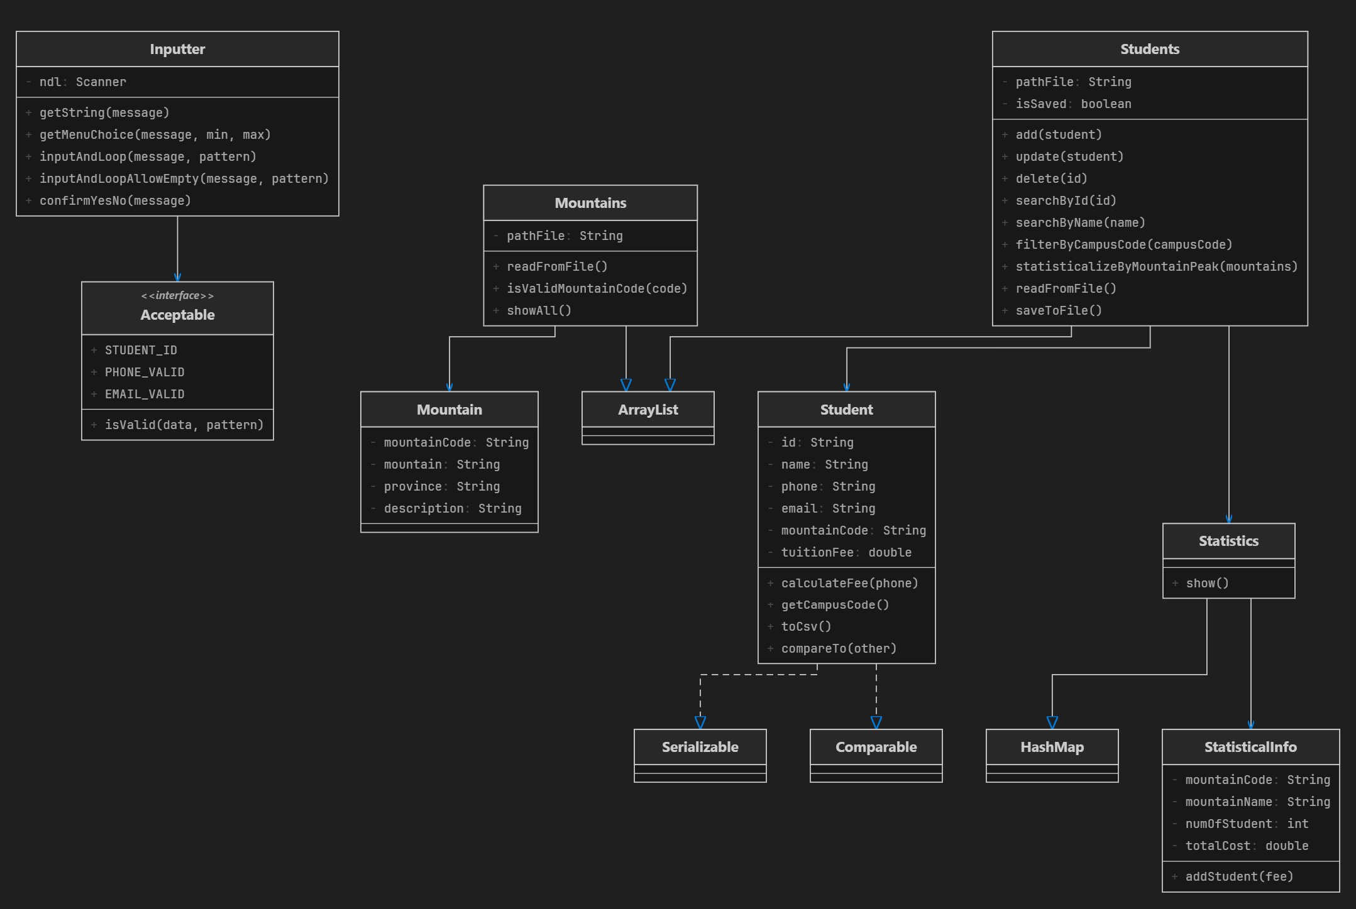
(Insert image: Class Diagram - System class relationships)
Key relationships in the Class Diagram:
- Student implements Serializable: enables serializing Student objects for .dat file storage.
- Student implements Comparable<Student>: enables comparing and sorting students by ID.
- Students extends ArrayList<Student>: the student list inherits from ArrayList.
- Mountains extends ArrayList<Mountain>: the mountain list inherits from ArrayList.
- Statistics extends HashMap<String, StatisticalInfo>: the statistics table uses HashMap.
- Inputter uses Acceptable: calls isValid() method for data validation.
- Students references Student; Statistics references StatisticalInfo.
2.3. Overall Flowchart
The overall flowchart describes the main workflow of the program from startup to exit. The program operates in a menu-driven loop.
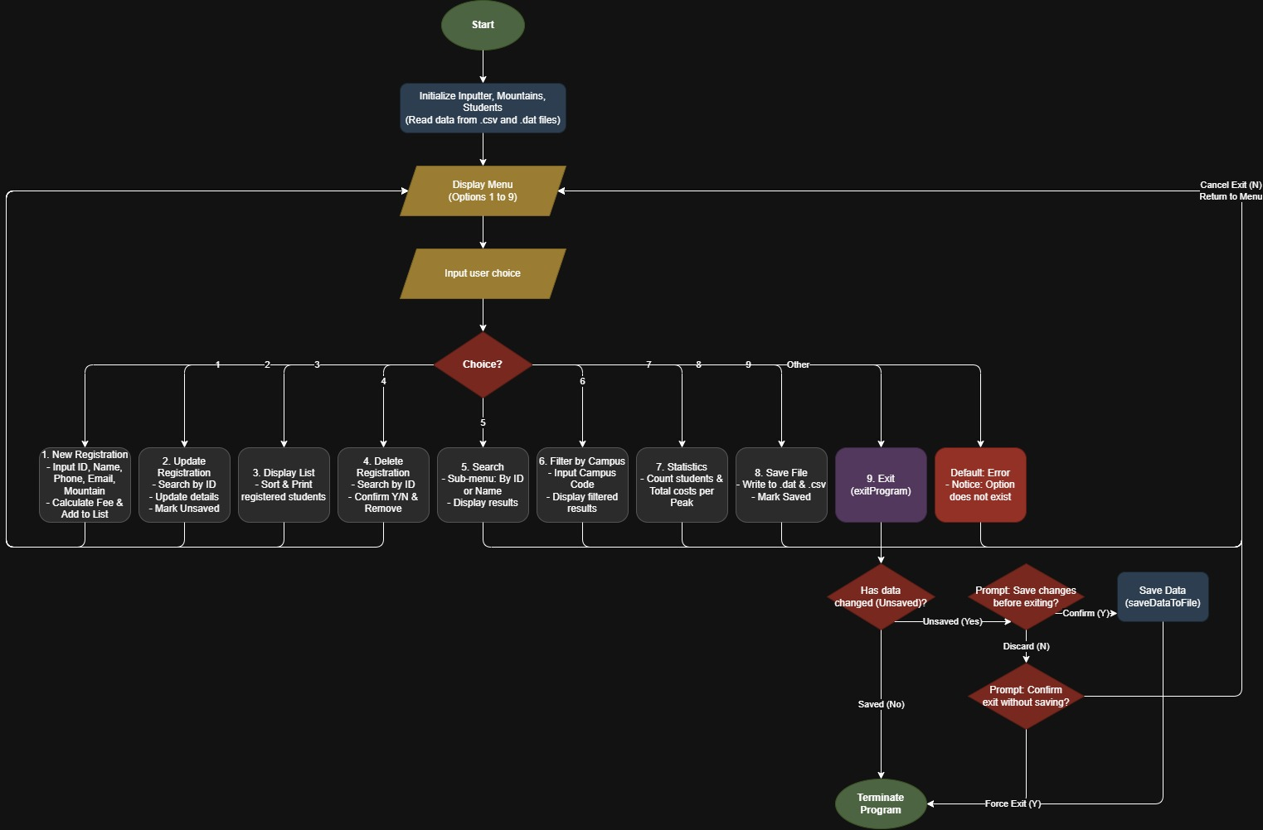
(Insert image: Overall Flowchart - Main program workflow)
Workflow description:
- Step 1: Startup - Load the mountain list from MountainList.csv.
- Step 2: Load registration data from registrations.dat (if it exists).
- Step 3: Display the main menu with 9 options.
- Step 4: The user enters a choice (validated 1-9).
- Step 5: Execute the corresponding feature.
- Step 6: Mark data as unsaved if any changes were made (Add/Update/Delete).
- Step 7: Return to Step 3 until the user chooses Exit (9).
- Step 8: If there is unsaved data, prompt to save -> End.

3. Detailed Class Descriptions

3.1. Interface Acceptable
Acceptable is an interface that contains Regex (Regular Expression) constants used for input data validation, and a static method isValid() to check whether a string matches a given regex pattern.
Constant | Regex Pattern | Meaning
STUDENT_ID | ^(?i)(SE|HE|DE|QE|CE)\d{6}$ | Student ID: 2-char campus code + 6 digits
CAMPUS_CODE | ^(?i)(SE|HE|DE|QE|CE)$ | Campus code: SE/HE/DE/QE/CE
NAME_VALID | ^[A-Za-zAa-yy\s]{2,20}$ | Name: 2-20 letters and spaces only
PHONE_VALID | ^0\d{9}$ | Phone: starts with 0, exactly 10 digits
VIETTEL_VALID | ^(032|033|...|086)\d{7}$ | Viettel carrier phone (discounted fee)
VNPT_VALID | ^(081|082|...|094)\d{7}$ | VNPT carrier phone (discounted fee)
EMAIL_VALID | ^[A-Za-z0-9+_.-]+@...+\.[A-Za-z]{2,}$ | Valid email format
YES_NO_VALID | ^[YyNn]$ | Confirmation: Y or N

Method isValid(String data, String pattern): Uses Pattern.matches() to check whether the data string matches the pattern. Returns true if it matches, false otherwise.

3.2. Class Inputter
Inputter is a utility class for handling keyboard (console) input. This class ensures all input data is validated before being returned.
Method | Description | Notes
getString(message) | Displays a prompt and reads a string | Returns trimmed string
getInt(message) | Reads an integer, loops until valid | Uses INTEGER_VALID regex
getDouble(message) | Reads a double, loops until valid | Uses DOUBLE_VALID regex
getMenuChoice(msg, min, max) | Reads a menu choice within [min, max] | Loops if out of range
inputAndLoop(msg, pattern) | Reads input and validates with regex | Does not allow empty input
inputAndLoopAllowEmpty(msg, pattern) | Same as above but allows empty (Enter) | Used during Update
confirmYesNo(message) | Asks for Y/N confirmation | Returns true if Y

3.3. Class Mountain
Mountain represents a mountain peak in the program. Each Mountain object stores the mountain code, name, province, and description.
Attribute | Data Type | Description
mountainCode | String | Mountain code (e.g., 1, 2, 3...)
mountain | String | Mountain name (e.g., Ham Rong Mountain)
province | String | Province/city where the mountain is located
description | String | Detailed description of the mountain

Special methods: toString() displays information in columnar format, equals() compares by mountainCode (case-insensitive), hashCode() is based on the uppercase mountainCode.

3.4. Class Mountains
Mountains extends ArrayList<Mountain> and manages the entire list of mountain peaks. It automatically reads data from MountainList.csv upon initialization.
Method | Description
Mountains() | Default constructor, reads MountainList.csv
Mountains(pathFile) | Constructor with custom file path
get(mountainCode) | Finds a Mountain by code (case-insensitive)
isValidMountainCode(code) | Checks whether a mountain code exists
dataToObject(text) | Converts a CSV line into a Mountain object
readFromFile() | Reads the entire CSV file, skips header and blank lines
showAll() | Displays the mountain list in a table with header

3.5. Class Student
Student represents a student who registered for the hiking challenge. This class implements Serializable (for binary file storage) and Comparable<Student> (for sorting by ID).
Attribute | Data Type | Description
id | String | Student ID (e.g., SE203056)
name | String | Student full name
phone | String | Phone number (10 digits, starts with 0)
email | String | Email address
mountainCode | String | Registered mountain peak code
tuitionFee | double | Registration fee (VND)

Important constants:
- DEFAULT_FEE = 6,000,000 VND - Default registration fee.
- DISCOUNT_RATE = 0.35 (35%) - Discount rate for Viettel/VNPT phone numbers.

Fee calculation logic (calculateFee):
- If the phone number belongs to Viettel or VNPT -> Fee = 6,000,000 x (1 - 0.35) = 3,900,000 VND.
- If the phone number belongs to another carrier -> Fee = 6,000,000 VND (no discount).

Note: When calling setPhone(), the registration fee is automatically recalculated. This ensures the fee is always accurate when the phone number is updated.

3.6. Class Students
Students extends ArrayList<Student> and manages the entire registration list. It supports CRUD operations, search, filter, statistics, and file I/O.
Method | Description | Notes
add(student) | Adds a student, checks for duplicate ID | Calls markUnsaved() on success
update(student) | Updates a student by ID | Calls markUnsaved() on success
delete(id) | Deletes a student by ID | Calls markUnsaved() on success
searchById(id) | Exact search by ID (case-insensitive) | Returns Student or null
searchByName(name) | Search by name (partial, case-insensitive) | Returns List<Student>
filterByCampusCode(campus) | Filters by first 2 characters of ID | e.g., SE, HE, DE...
showAll() | Displays the entire list | Sorted by ID
showAll(list) | Displays a sub-list | Used for search/filter results
readFromFile() | Reads .dat file (ObjectInputStream) | Called in constructor
saveToFile() | Saves .dat file + exports CSV | Marks as saved afterward
statisticalizeByMountainPeak() | Generates statistics by peak | Creates Statistics object

3.7. Class StatisticalInfo
StatisticalInfo stores statistics for a specific mountain peak, including the mountain code, mountain name, number of registered students, and total fee.
Attribute | Data Type | Description
mountainCode | String | Mountain peak code
mountainName | String | Mountain peak name
numOfStudent | int | Number of registered students
totalCost | double | Total registration fee (VND)

Method addStudent(fee): Increments numOfStudent by 1 and adds fee to totalCost.

3.8. Class Statistics
Statistics extends HashMap<String, StatisticalInfo> and performs statistical analysis of registration count and total fees grouped by mountain peak.
Statistics logic (statisticalize):
- Iterates through the entire student list.
- For each student, retrieves the mountainCode.
- If no StatisticalInfo exists for that mountainCode, creates a new one and looks up the mountain name from Mountains.
- Calls addStudent(fee) to accumulate the count and total.
- Displays a statistics table with columns: Code, Peak Name, Number of Participants, Total Cost.

3.9. Class Main
Main is the primary orchestration class containing the main() method and static methods corresponding to each menu feature. Main initializes 3 core objects: Inputter (input handling), Mountains (mountain list), and Students (student list).
Method | Menu | Feature
addNewRegistration() | 1 | Register a new student
updateRegistration() | 2 | Update registration information
displayRegisteredList() | 3 | Display the registered list
deleteRegistration() | 4 | Delete a registration
searchByName() | 5 | Search by ID or name
filterByCampus() | 6 | Filter by campus
showStatistics() | 7 | Statistics by mountain peak
saveDataToFile() | 8 | Save data to file
exitProgram() | 9 | Exit the program

4. User Guide for Each Feature

4.1. Main Menu
When the program starts, the main menu is displayed. The user enters a number from 1 to 9 to select the corresponding feature. If an invalid input is entered (letters, out-of-range numbers, special characters), the program prompts for re-entry without crashing.
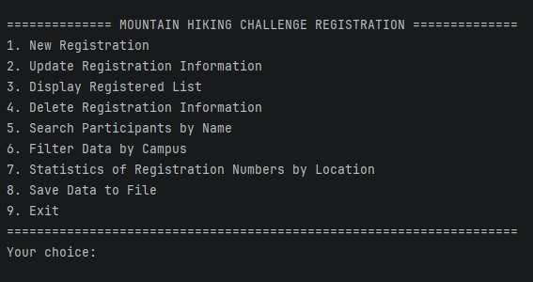
(Insert image: Main Menu interface upon program startup)
Menu features:
1. New Registration: Register a new student for the hiking challenge.
2. Update Registration Information: Update information of an already registered student.
3. Display Registered List: Display the entire registration list in table format.
4. Delete Registration Information: Delete a student's registration.
5. Search Participants by Name: Search for students by ID or name.
6. Filter Data by Campus: Filter the list by campus (SE/HE/DE/QE/CE).
7. Statistics of Registration Numbers by Location: Statistics of count and total fee by mountain peak.
8. Save Data to File: Save data to .dat file and export CSV.
9. Exit: Exit the program (prompts to save if there is unsaved data).

4.2. Feature 1: New Registration
Description: Allows entering new student information to register for the hiking challenge.
Steps:
- Step 1: Select option 1 from the main menu.
- Step 2: Enter Student ID in the format: SE/HE/DE/QE/CE + 6 digits (e.g., SE203056). If the ID already exists, an error is displayed and re-entry is required.
- Step 3: Enter Name: 2-20 characters, letters and spaces only.
- Step 4: Enter Phone: 10 digits, starting with 0.
- Step 5: Enter Email: valid email format (e.g., example@gmail.com).
- Step 6: The list of 13 mountain peaks is displayed. Enter the desired mountain code (1-13).
- Step 7: The system automatically calculates the fee: 3,900,000 VND (Viettel/VNPT) or 6,000,000 VND (other).
- Step 8: A success message with the registration fee is displayed.
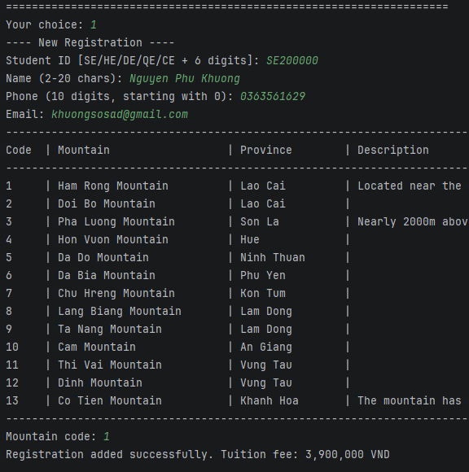
(Insert image: New Registration screen - entering complete student information)
Error handling during registration:
- Invalid ID format -> "Invalid format, please re-enter."
- Duplicate ID -> "Student ID already exists. Please try again."
- Invalid name, phone, or email -> "Invalid format, please re-enter."
- Invalid mountain code -> "Invalid mountain code. Please choose a code from the list."
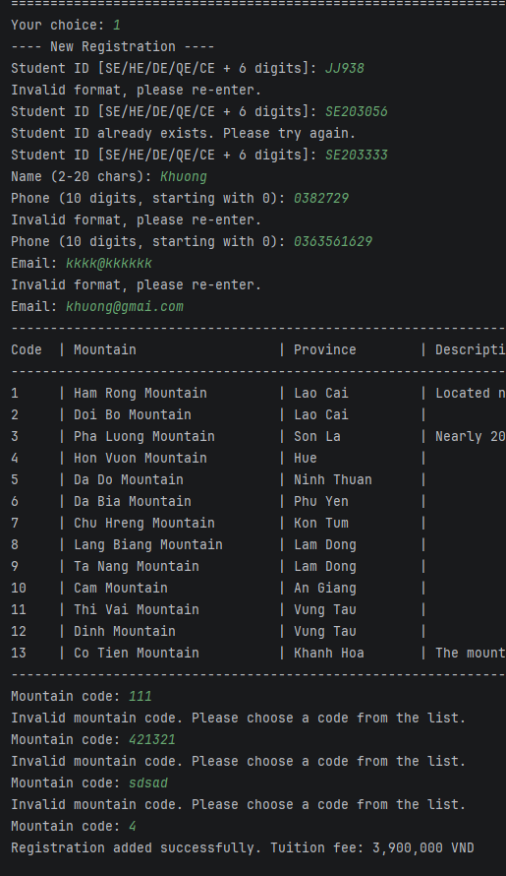
(Insert image: Error message screen when entering invalid data)

4.3. Feature 2: Update Registration Information
Description: Updates the registration information of an existing student.
Steps:
- Step 1: Select option 2 from the main menu.
- Step 2: Enter the Student ID to update.
- Step 3: If the ID does not exist -> "This student has not registered yet." -> Return to menu.
- Step 4: Display the student's current information.
- Step 5: For each field (Name, Phone, Email, Mountain Code): enter a new value or press Enter to keep the current value.
- Step 6: If the Phone is changed, the registration fee is automatically recalculated.
- Step 7: Display the updated information.
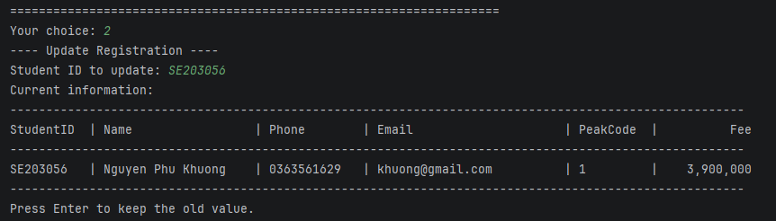
(Insert image: Update screen - displaying old information and entering new values)
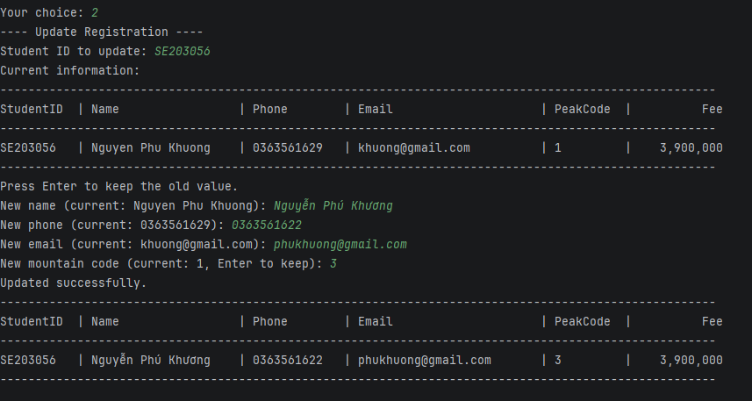
(Insert image: Successful update result)
Note: The "press Enter to keep current value" feature is very convenient when only 1-2 fields need to be modified without re-entering everything.

4.4. Feature 3: Display Registered List
Description: Displays the entire list of registered students in table format, sorted by Student ID in ascending order.
Steps:
- Step 1: Select option 3 from the main menu.
- Step 2: The table is displayed with columns: StudentID, Name, Phone, Email, PeakCode, Fee.
- If no one has registered: "No students have registered yet."
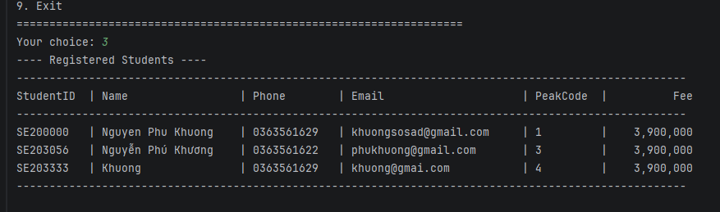
(Insert image: Display screen showing the full registration list in table format)

4.5. Feature 4: Delete Registration
Description: Removes a student's registration from the list.
Steps:
- Step 1: Select option 4 from the main menu.
- Step 2: Enter the Student ID to delete.
- Step 3: If the ID does not exist -> error message -> return to menu.
- Step 4: Display the student's detailed information for confirmation.
- Step 5: Prompt for confirmation: "Are you sure you want to delete this registration? (Y/N)".
- Step 6: If Y -> delete and display "The registration has been successfully deleted."
- Step 7: If N -> "Deletion cancelled." -> return to menu.
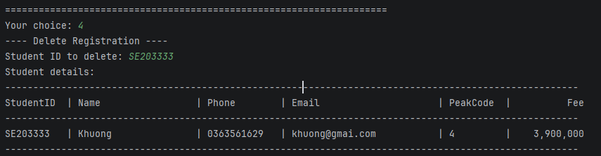
(Insert image: Delete screen - confirmation before deletion)
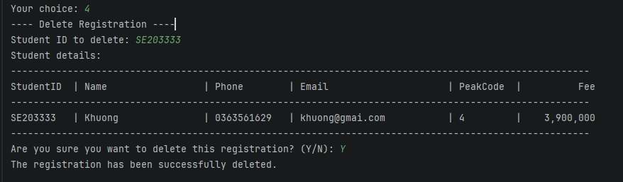
(Insert image: Result after successful deletion)

4.6. Feature 5: Search Participants
Description: Search for students by exact Student ID or by partial name (case-insensitive).
Steps:
- Step 1: Select option 5 from the main menu.
- Step 2: A sub-menu appears: 1. Search by Student ID / 2. Search by Name.
- Step 3: If option 1: Enter Student ID -> exact search -> display result or "No one matches the search criteria!"
- Step 4: If option 2: Enter (partial) name -> find all students whose name contains the input (case-insensitive) -> display result table.
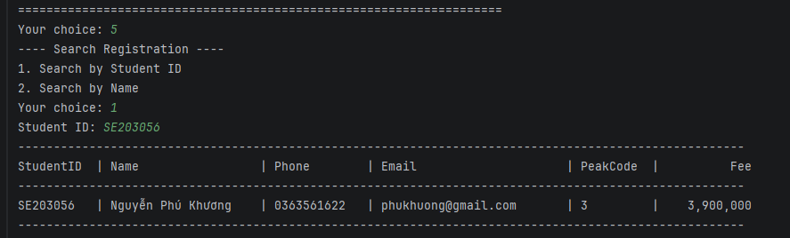
(Insert image: Search by ID screen - result found)
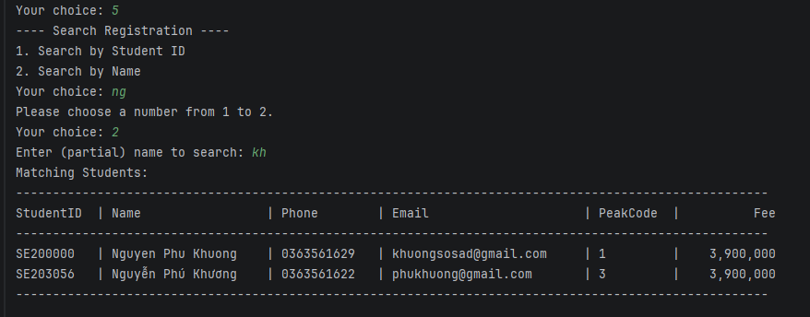
(Insert image: Search by Name screen - multiple matching results)
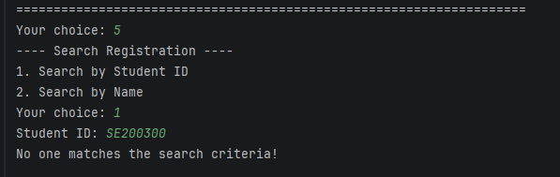
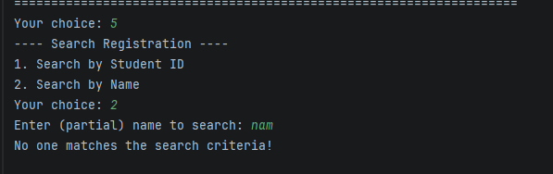
(Insert image: Search screen - no results found)

4.7. Feature 6: Filter by Campus
Description: Filters the student list by campus code (first 2 characters of the Student ID).
Campus Code | Campus Name
CE | FPT Can Tho
DE | FPT Da Nang
HE | FPT Ha Noi
SE | FPT Ho Chi Minh
QE | FPT Quy Nhon

Steps:
- Step 1: Select option 6 from the main menu.
- Step 2: Enter the campus code (e.g., SE).
- Step 3: Display the list of students under that campus, or "No students have registered under this campus." if none found.
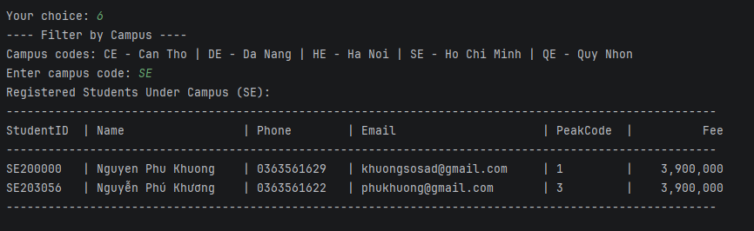
(Insert image: Filter by Campus screen - displaying results)

4.8. Feature 7: Statistics by Mountain
Description: Generates statistics of the number of registered students and total fee per mountain peak.
Steps:
- Step 1: Select option 7 from the main menu.
- Step 2: The statistics table is displayed with columns: Code, Peak Name, Number of Participants, Total Cost.
- If there is no data: "No registration data available for statistics."
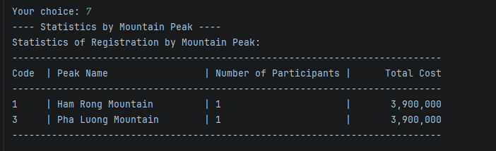
(Insert image: Statistics by Mountain screen - results table)

4.9. Feature 8: Save Data to File
Description: Saves all registration data to 2 files:
- registrations.dat - Binary file, uses ObjectOutputStream to serialize ArrayList<Student>.
- registrations.csv - Text CSV file, easily opened with Excel. Columns: StudentID, Name, Phone, Email, MountainCode, TuitionFee.

Steps:
- Step 1: Select option 8 from the main menu.
- Step 2: The system automatically saves and displays "Registration data has been successfully saved."
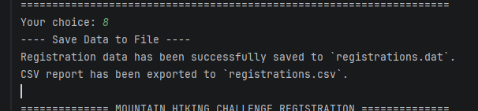
(Insert image: Successful data save screen)
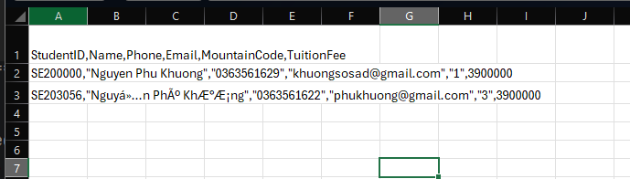
(Insert image: Contents of registrations.csv opened in Excel or Notepad)

4.10. Feature 9: Exit Program
Description: Exits the program with unsaved data checking.
Exit workflow:
- Select option 9 from the main menu.
- If there is NO unsaved data -> Exit immediately, display "Goodbye!".
- If there IS unsaved data:
- a. Prompt: "You have unsaved changes. Do you want to save before exiting? (Y/N)"
- b. If Y -> Save to file -> Exit.
- c. If N -> Prompt again: "Are you sure you want to exit without saving? (Y/N)"
- d. If Y -> Exit without saving.
- e. If N -> Return to menu (do not exit).
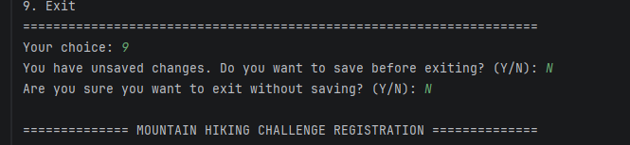
(Insert image: Exit screen - prompt to save when there is unsaved data)

5. Overall Workflow

5.1. Program Overall Flowchart
The flowchart below describes the overall workflow of the program from start to finish. The program operates in a menu-driven model (loop), meaning after completing a feature, the system returns to the main menu until the user selects Exit.

(Insert image: Overall Flowchart - Complete program workflow)
Workflow explanation:
Start -> Load MountainList.csv into Mountains -> Load registrations.dat into Students (if file exists) -> Display Menu -> Read user choice -> Execute feature -> Return to Menu (loop) -> When Exit is selected -> Check unsaved data -> Prompt to save -> End.

5.2. Sequence Diagram - New Registration
The Sequence Diagram describes the interaction sequence between objects when performing the New Registration feature. Participating objects: Operator, Main, Inputter, Mountains, Students, Student.

Sequence Diagram explanation:
- 1. Operator selects New Registration from the menu.
- 2. Main calls Inputter to input and validate ID, Name, Phone, Email.
- 3. Main calls Students.searchById() to check for duplicate ID.
- 4. Main calls Mountains.isValidMountainCode() to validate the mountain code.
- 5. Main creates a new Student object and calls calculateFee() to compute the fee.
- 6. Main calls Students.add() to add the student to the list and marks unsaved.
- 7. Main displays a success message to the Operator.

6. Sample Data

6.1. MountainList.csv File
The MountainList.csv file contains a list of 13 mountain peaks, loaded when the program starts. Structure: Code, Mountain, Province, Description.
Code | Mountain | Province | Description
1 | Ham Rong Mountain | Lao Cai | Near Sa Pa center, highest point 1850m
2 | Doi Bo Mountain | Lao Cai
3 | Pha Luong Mountain | Son La | Nearly 2000m, the Roof of Moc Chau
4 | Hon Vuon Mountain | Hue
5 | Da Do Mountain | Ninh Thuan
6 | Da Bia Mountain | Phu Yen
7 | Chu Hreng Mountain | Kon Tum
8 | Lang Biang Mountain | Lam Dong
9 | Ta Nang Mountain | Lam Dong
10 | Cam Mountain | An Giang
11 | Thi Vai Mountain | Vung Tau
12 | Dinh Mountain | Vung Tau
13 | Co Tien Mountain | Khanh Hoa | Has 3 peaks; conquer peak 1 only

6.2. registrations.csv File
The registrations.csv file is exported when the user selects Save Data. This is a text file that can be opened with Excel.
StudentID | Name | Phone | Email | MountainCode | TuitionFee
SE203056 | Nguyen Phu Khuong | 0363561629 | khuong@gmail.com | 1 | 3,900,000

7. Data Validation Rules
The system applies strict input data validation using Regular Expressions (Regex). The table below summarizes the validation rules for each data field.
Field | Rule | Valid Examples | Invalid Examples
Student ID | 2-char campus code (SE/HE/DE/QE/CE)  + 6 digits | SE203056  HE180001 | AB123456  SE12345  SE1234567
Name | 2-20 characters, letters  and spaces only | Nguyen Van A  Le Thi B | A  12345  Name longer than 20 chars abc
Phone | 10 digits, starts with 0 | 0363561629  0912345678 | 123456789  0123  abcdefghij
Email | user@domain.ext  (letters, digits, +, _, ., -) | abc@gmail.com  test_1@fpt.edu.vn | @gmail.com  abc@  abc.gmail.com
Mountain Code | Must exist in the  MountainList.csv list (1-13) | 1  5  13 | 0  14  abc
Campus Code | SE, HE, DE, QE, or CE  (case-insensitive) | SE  he  DE | AB  SF  123
Menu Choice | Integer from 1 to 9 | 1  5  9 | 0  10  abc
Confirm (Y/N) | Y or N  (case-insensitive) | Y  n | yes  no  1

Registration fee calculation rules:
Carrier | Prefix Codes | Registration Fee
Viettel | 032, 033, 034, 035, 036, 037, 038, 039, 096, 097, 098, 086 | 3,900,000 VND (35% discount)
VNPT | 081, 082, 083, 084, 085, 088, 091, 094 | 3,900,000 VND (35% discount)
Other (Mobifone, ...) | Other prefix codes | 6,000,000 VND (no discount)

8. Conclusion

8.1. Achievements
- Successfully completed all 9 features as required by the LAB211 assignment.
- Applied Object-Oriented Programming (OOP) with a clear structure of 9 classes/interfaces.
- Implemented strict input data validation using Regex; the program does not crash on invalid input.
- Automatic fee calculation based on phone carrier (Viettel/VNPT receive 35% discount).
- Reads mountain data from CSV file; saves registrations to binary file (.dat) and exports CSV.
- Smart exit handling: warns the user when there is unsaved data.
- Displays data in formatted tables with headers, dividers, and sorted by ID.
- Code exceeds 200 LOC with clear variable/method naming following conventions.

8.2. Applied Knowledge
- OOP: Class, Interface, Inheritance, Polymorphism, Encapsulation.
- Java Collections: ArrayList, HashMap, Collections.sort().
- Java I/O: BufferedReader, FileReader, ObjectInputStream/ObjectOutputStream, BufferedWriter.
- Serialization: Storing Java objects to binary file.
- Comparable: Sorting objects by custom criteria.
- Regex: Validating input data formats.
- Design Pattern: Menu-driven architecture, Separation of Concerns.

8.3. Limitations and Future Improvements
Limitations:
- No graphical user interface (GUI); the application is console-based only.
- No multi-language support (Vietnamese accented names may encounter encoding issues).
- No automated unit tests.

9. Feature Extension – Volunteer Management

9.1. Introduction to the New Feature
In this extended version, the Mountain Hiking Challenge Registration system is supplemented with the Volunteer Management module. The objectives of this extension are:
- Refactoring: Apply the Inheritance principle by creating an abstract class named Person as the common superclass for both Student and Volunteer, which helps to reuse source code and comply with OOP principles.
- Adding Volunteer module: Allows managing the list of volunteers supporting the mountain hiking trips, including CRUD operations and shift assignment functions (Assign to Shift).
- Extending Acceptable: Adding new regex patterns to validate the input data for Volunteer.
- Extending Main Menu: Add menu option 9 (Volunteer Management) with its own sub-menu.
New files added:
No. | File Name | Description
1 | Person.java | Abstract class – common superclass
2 | Skill.java | Enum – list of volunteer skills
3 | Volunteer.java | Class – Volunteer entity
4 | Volunteers.java | Class – manages the list of Volunteers
Modified files:
No. | File Name | Modifications
1 | Student.java | Refactored: inherits from Person instead of declaring id and name directly
2 | Acceptable.java | Added 3 new regex patterns for Volunteer validation
3 | Main.java | Added Volunteer Management menu and its corresponding handling methods

9.2. Class Hierarchy Design (Inheritance – Abstract Class)
Prior to the extension, the Student class had the id and name attributes declared directly. When adding the Volunteer object (which also requires id and name), code duplication would be inevitable without refactoring.
Solution: Create an abstract class Person containing common attributes and methods, then have both Student and Volunteer inherit from Person.
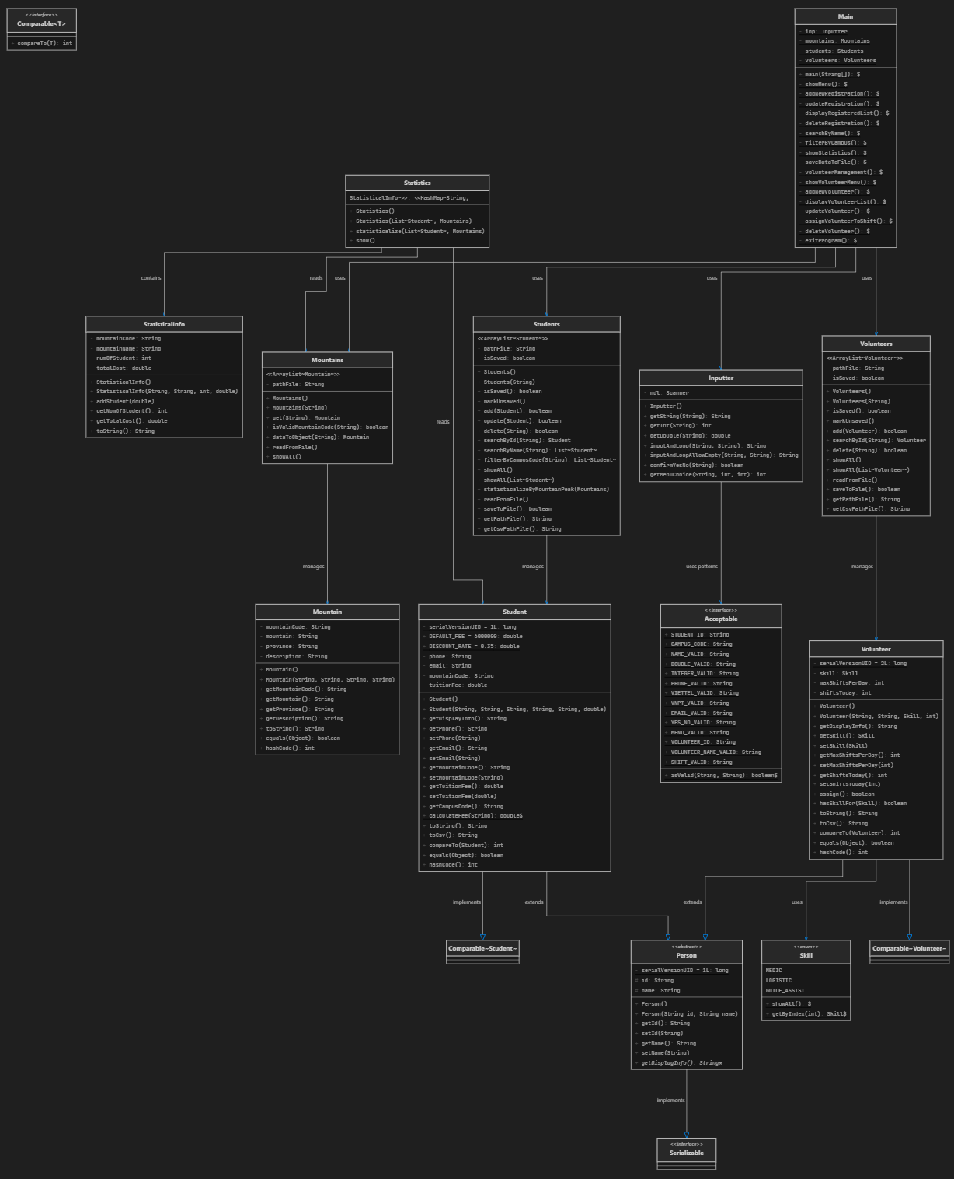
(Please insert image: Overall System Class Diagram after refactoring – including all classes)

9.3. Description of New Classes

9.3.1. Abstract Class – Person
File: Person.java | Lines of code: 36 lines
Component | Description
abstract class Person | Abstract class, cannot be instantiated directly
implements Serializable | Allows serialization/deserialization of objects to save to the .dat file
protected String id, name | Common attributes, accessible from subclasses
abstract getDisplayInfo() | Abstract method – forces subclasses to override it

9.3.2. Enum – Skill
File: Skill.java | Lines of code: 20 lines
Value | Meaning
MEDIC | Volunteer with medical/first aid skills
LOGISTIC | Volunteer responsible for logistics and transportation
GUIDE_ASSIST | Volunteer assisting the tour guides

9.3.3. Class – Volunteer
File: Volunteer.java | Lines of code: 115 lines
Declared to inherit from Person (public class Volunteer extends Person implements Comparable<Volunteer>).
Attribute | Type | Description
skill | Skill | Specialized skill
maxShiftsPerDay | int | Maximum number of shifts per day (1–3)
shiftsToday | int | Number of shifts accepted for the current day
Method | Description
assign() | Assign shift: increments shiftsToday by 1 if max is not reached. Returns true if successful.
hasSkillFor(Skill) | Checks if the volunteer has the required skill. GENERAL slot accepts anyone.
getDisplayInfo() | Overridden from Person – displays information in a formatted table.
toCsv() | Converts the information to CSV format.

9.3.4. Class – Volunteers
File: Volunteers.java | Lines of code: 150 lines
Inherits from ArrayList<Volunteer> and manages the Volunteer list. Supports methods such as add, searchById, delete, showAll, readFromFile, saveToFile (saves to volunteers.dat and exports CSV).

9.4. Modifications to Existing Classes

9.4.1. Student (refactored)
Before (Old) | After (New)
implements Serializable, Comparable<Student> | extends Person implements Comparable<Student>
Declared private String id; private String name; | Inherits id and name from Person (protected)
Constructor: this.id = id; this.name = name; | Constructor: super(id, name);
No getDisplayInfo() method | Overrides getDisplayInfo() returning toString()

9.4.2. Acceptable (updated)
Pattern | Explanation
VOLUNTEER_ID | Starts with "VL" (case-insensitive) + 3 digits
VOLUNTEER_NAME_VALID | 3–30 alphabetic characters (including Vietnamese) + spaces
SHIFT_VALID | Accepts values 1, 2, or 3 only

9.4.3. Main (updated)
Main Menu modifications: Expanded from 9 options to 10 options, adding "9. Volunteer Management".
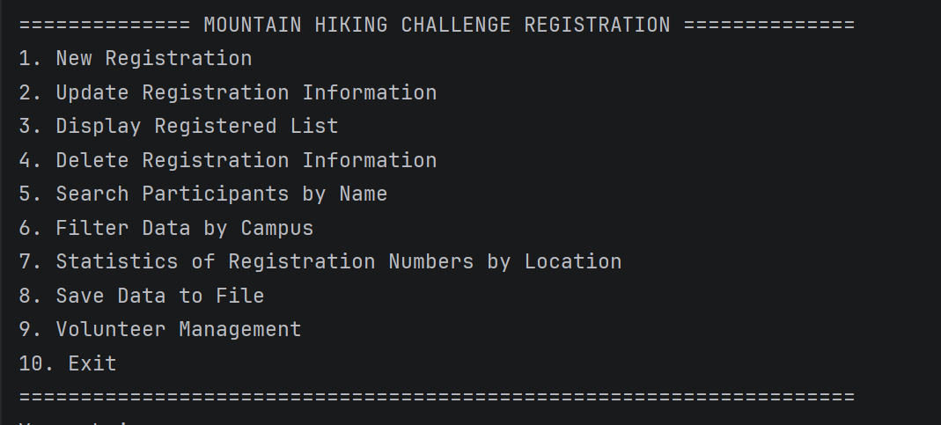
(Please insert image: Screenshot of Main Menu showing all 10 options)
Added Volunteer Management sub-menu with 6 features (Add, Display, Update, Assign, Delete, Back).
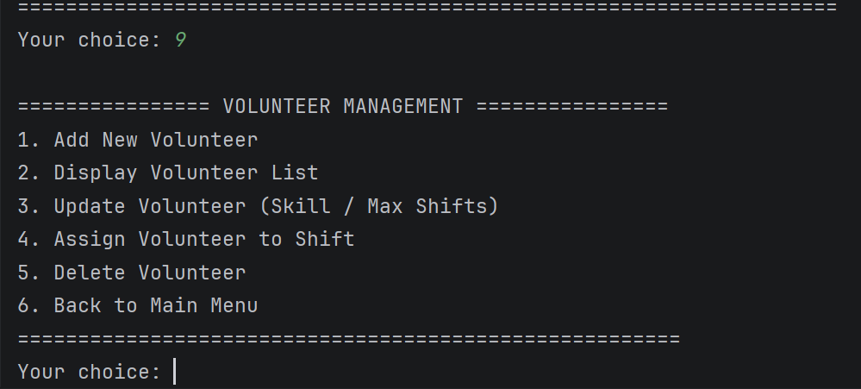
(Please insert image: Screenshot of Volunteer Management sub-menu)

9.5. Updated Class Diagram
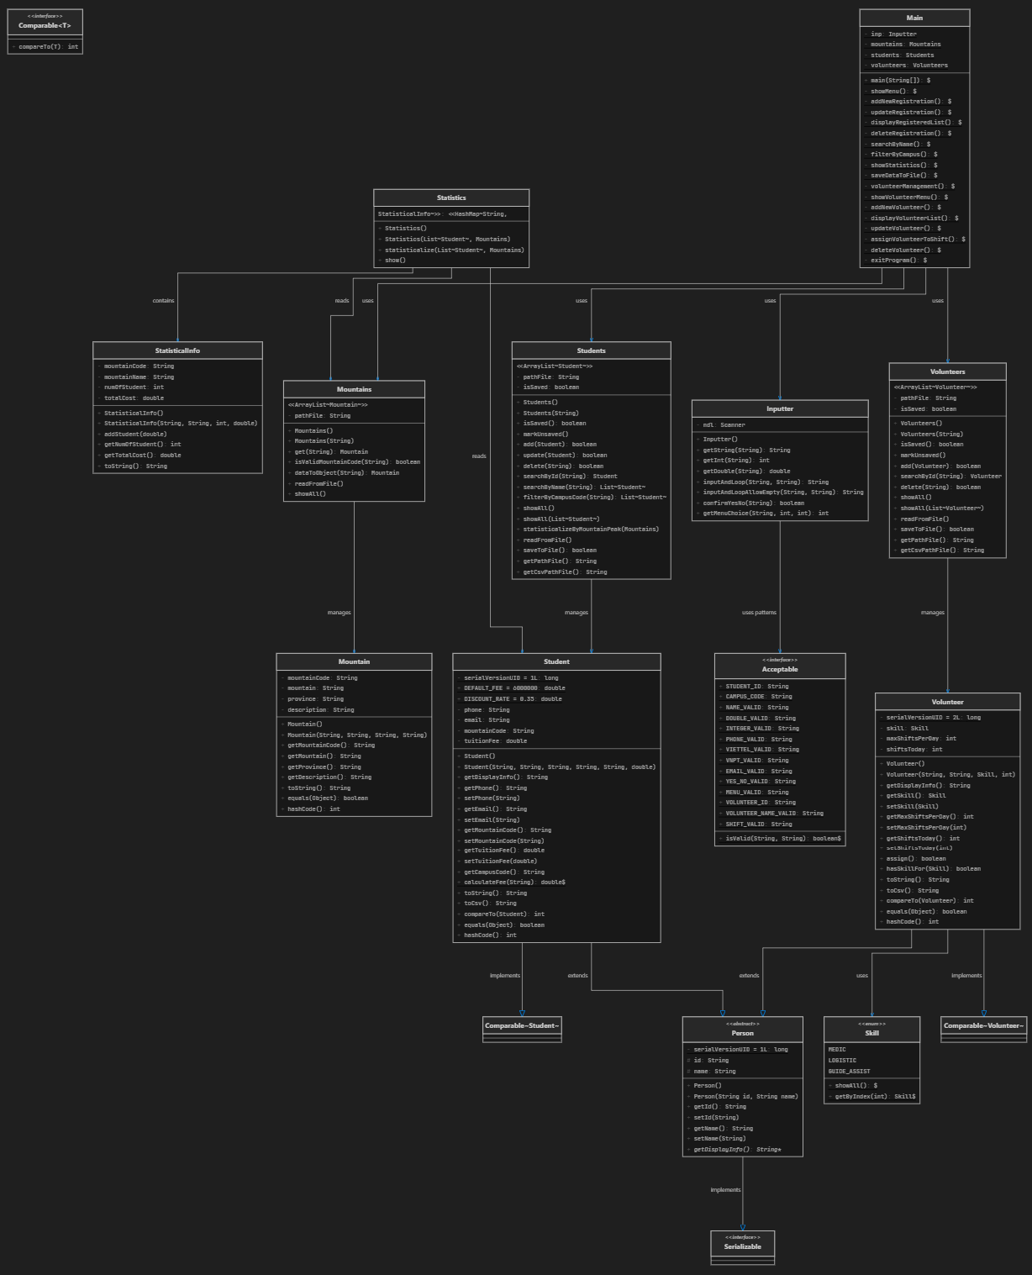
(Please insert image: Complete Class Diagram (PlantUML or Draw.io) – including all 13 classes/interfaces/enums)

9.6. Volunteer Management Features

9.6.1. Add New Volunteer
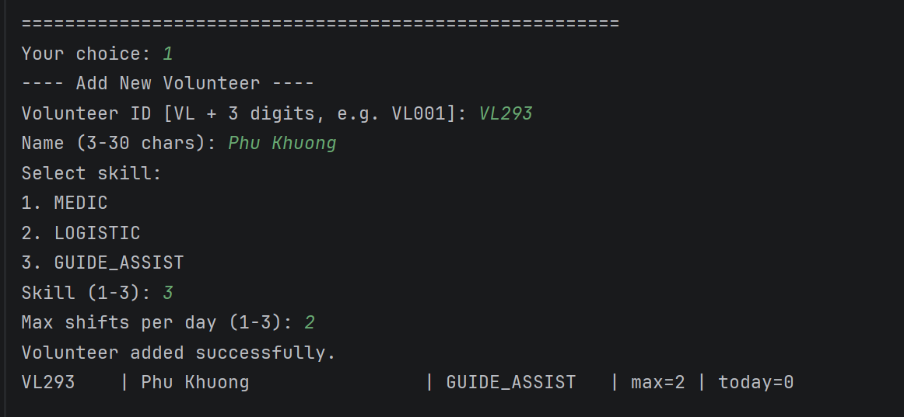
(Please insert image: Screenshot of successfully adding a new Volunteer)
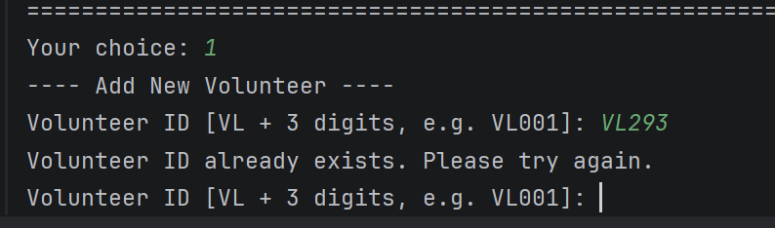
(Please insert image: Screenshot of duplicate ID entry – displaying error message)

9.6.2. Display Volunteer List
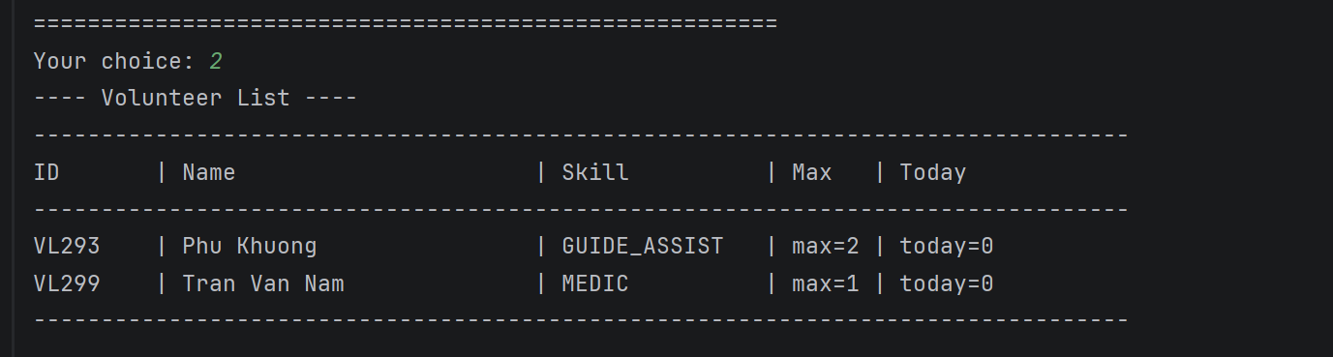
(Please insert image: Screenshot of the full Volunteer list)

9.6.3. Update Volunteer
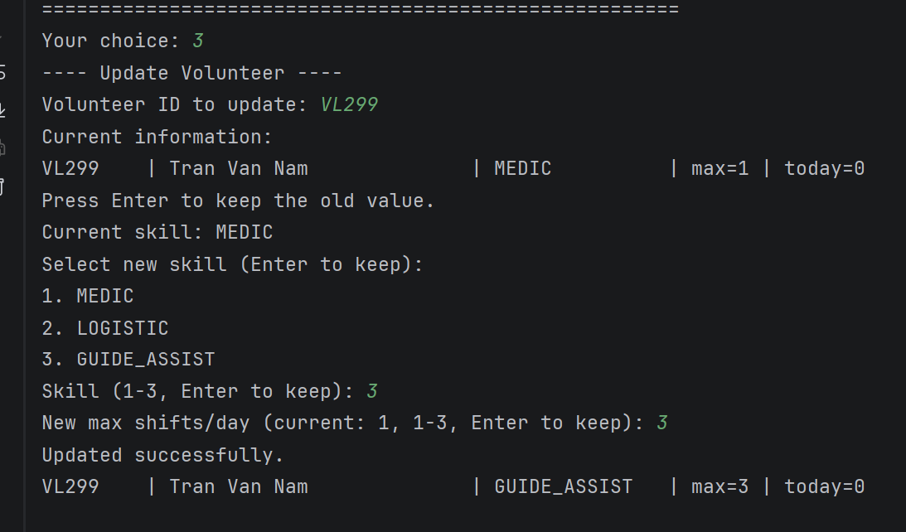
(Please insert image: Screenshot of Update Volunteer process – showing old and new information)

9.6.4. Assign Volunteer to Shift
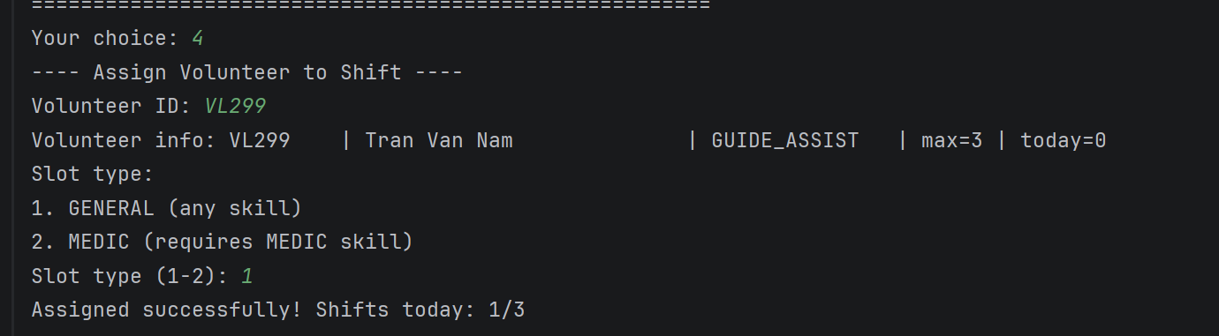
(Please insert image: Screenshot of successful Assignment)
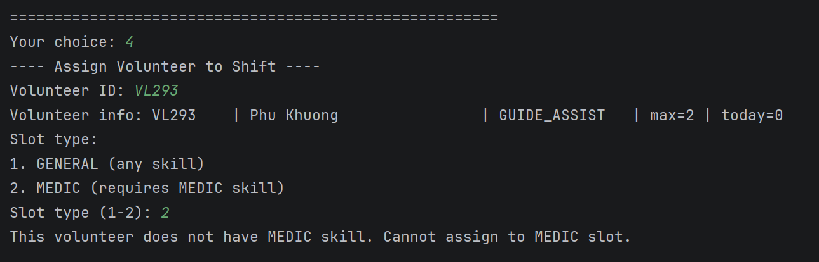
(Please insert image: Screenshot of insufficient skill for MEDIC slot error)

9.6.5. Delete Volunteer
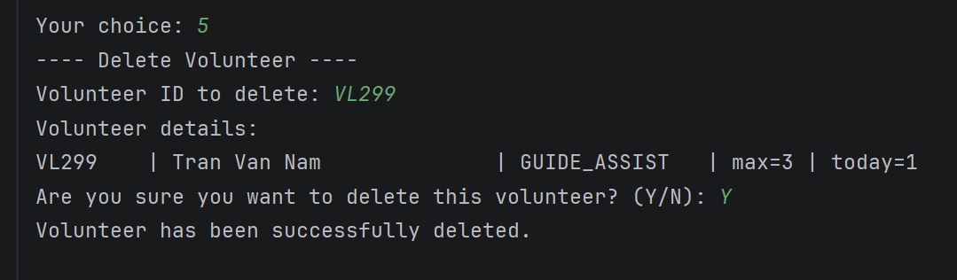
(Please insert image: Screenshot of deleting Volunteer – confirming with Y)
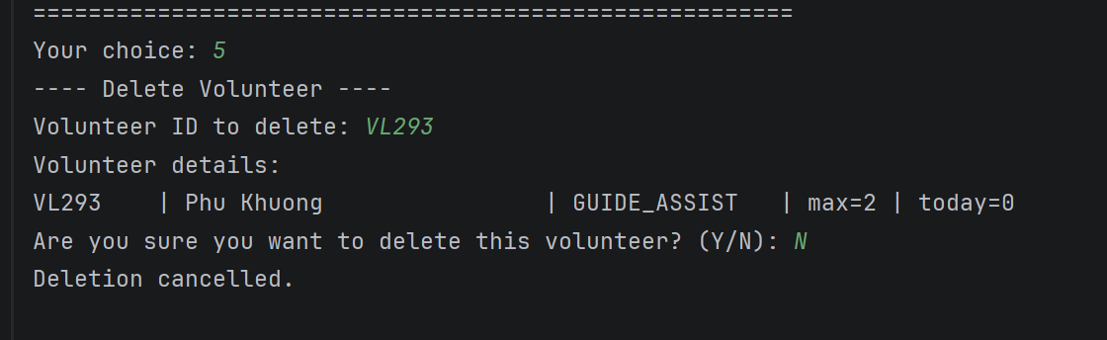
(Please insert image: Screenshot of cancelling deletion – pressing N)

9.7. Volunteer Data Storage Integration
The saveDataToFile() method was updated to save both Student (registrations.dat) and Volunteer (volunteers.dat) data.
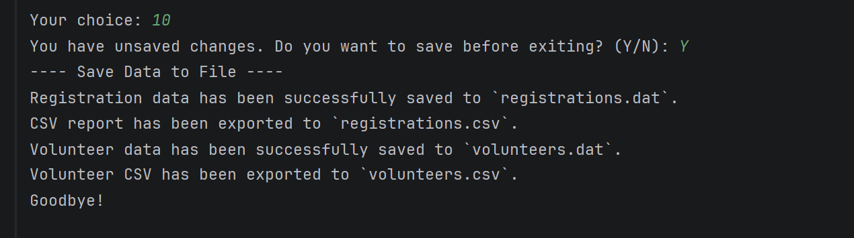
(Please insert image: Screenshot of Save Data result – showing both Student and Volunteer saved successfully)
Exit Program: Checks both data sources. Warns if any data is unsaved.
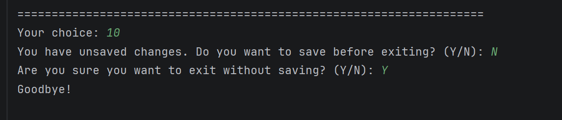
(Please insert image: Screenshot of Exit prompt when there are unsaved changes)

9.8. Conclusion of the Extension
The Volunteer Management extension has successfully:
- Applied Inheritance: Created abstract class Person as the superclass.
- Applied Polymorphism: getDisplayInfo() is overridden in each subclass.
- Applied Encapsulation: Utilized Skill enum, and Volunteers class to manage the list.
- Integrated fully and operated smoothly with the existing Student system.
The total lines of code after the extension reached 1,518 lines with 13 class/enum/interface files.

ADDITIONAL REPORT CONTENT - FEATURE EXTENSION

10. Feature Extension – Role-Based Access Control (RBAC)

10.1. Introduction to the Authorization Feature
In this next extended version, the system is supplemented with Authentication (Login) and Role-Based Access Control (RBAC). Previously, anyone running the program could use every function; now each user must log in and only sees/uses the functions appropriate to their role.
- Authentication: Users must log in with a username/password before entering the system (up to 3 attempts).
- Authorization (RBAC): Each account is bound to a Role; each Role owns a set of Permissions. The menu is generated dynamically – only functions the user is permitted to use are displayed.
- Applying OOP: Separating Permission – Role – Account into independent components, each class responsible for its own task (Single Responsibility).
- Account management: Added an Account Management menu for administrators (ADMIN) to view, add, and delete accounts.
- Clean code refactor: Replaced the bulky switch-case menu with a "menu engine" using a list of permission-aware MenuItem objects.
New files added:
No. | File Name | Lines | Description
1 | Permission.java | 20 | Enum – lists the functional permissions of the system
2 | Role.java | 44 | Enum – roles, each bound to a set of Permissions
3 | Account.java | 70 | Class – user account, inherits from Person
4 | Accounts.java | 128 | Class – manages the account list and handles login
5 | MenuItem.java | 24 | Class – a menu entry bound to a permission and an action
Modified files:
No. | File Name | Modifications
1 | Main.java | Added login flow, permission-based dynamic menu, and Account Management; replaced switch-case with a menu engine
2 | Acceptable.java | Added 2 regex patterns: USERNAME_VALID and PASSWORD_VALID
3 | Person.java | Reused as the superclass for Account (id = username, name = display name)

10.2. The RBAC Model
RBAC (Role-Based Access Control) is an access-control model based on roles. Instead of assigning permissions directly to each user, the system maps: User → Role → Set of Permissions. This centralizes permission management, makes it easy to extend, and aligns well with OOP principles.
Relationship between components:
Component | Role in the Model
Account | Represents a logged-in user; holds a reference to one Role.
Role | Represents a role; holds a Set<Permission> (using EnumSet).
Permission | Represents an access right to a specific group of functions.
MenuItem | Each menu entry declares its required permission; it checks whether the account is allowed.

10.3. Description of New Components

10.3.1. Enum – Permission
File: Permission.java | Lines of code: 20 lines
Lists 8 permissions corresponding to functional groups, each with a description:
Permission | Allows
CREATE_REGISTRATION | Create a new registration
UPDATE_REGISTRATION | Update registration information
VIEW_REGISTRATION | View / search / filter the registration list
DELETE_REGISTRATION | Delete a registration
VIEW_STATISTICS | View statistics by location
SAVE_DATA | Save data to file
MANAGE_VOLUNTEER | Manage volunteers
MANAGE_ACCOUNT | Manage accounts (ADMIN only)

10.3.2. Enum – Role
File: Role.java | Lines of code: 44 lines
Each role constant is initialized with an EnumSet<Permission>. The method has(Permission) checks whether the role contains that permission.
Role | Permission Scope
ADMIN | Full access (EnumSet.allOf) – every function including account management
STAFF | Create, update, view, statistics, save and volunteer management (no delete, no account management)
VIEWER | View list and statistics only (read-only)

10.3.3. Class – Account
File: Account.java | Lines of code: 70 lines
Inherits from Person (public class Account extends Person), reusing id as the username and name as the display name.
Component | Description
password (private) | The password is fully encapsulated with NO getter to prevent leakage.
role (Role) | The role of the account.
authenticate(pwd) | The account validates the entered password itself (returns true/false).
can(Permission) | Delegates to Role for checking: role.has(permission).
getDisplayInfo() | Overridden from Person – displays username | name | role.

10.3.4. Class – Accounts
File: Accounts.java | Lines of code: 128 lines
Inherits from ArrayList<Account>, manages the account list and saves/loads the accounts.dat file (Serialization). If the file is empty, the system automatically seeds 3 default accounts. It provides login(username, password) returning an Account if valid, plus searchByUsername, add, delete, and showAll.

10.3.5. Class – MenuItem
File: MenuItem.java | Lines of code: 24 lines
Encapsulates a menu entry consisting of: a display label, a required Permission, and an action (Runnable). The method isAllowedFor(account) returns true when the entry requires no permission or the account has the matching permission – so the menu only shows entries the user is allowed to access.

10.4. Modifications to Existing Classes

10.4.1. Main (refactored – menu engine + login)
Before (Old) | After (New)
Enters the menu directly, no login | Requires login() first, up to 3 attempts
Large switch-case (case 1..10) | runMenu() iterates a list of MenuItem, generating the menu dynamically
Fixed menu for everyone | Only shows entries the currentUser is permitted to use (visibleItems)
No account management | Added Account Management menu (ADMIN)
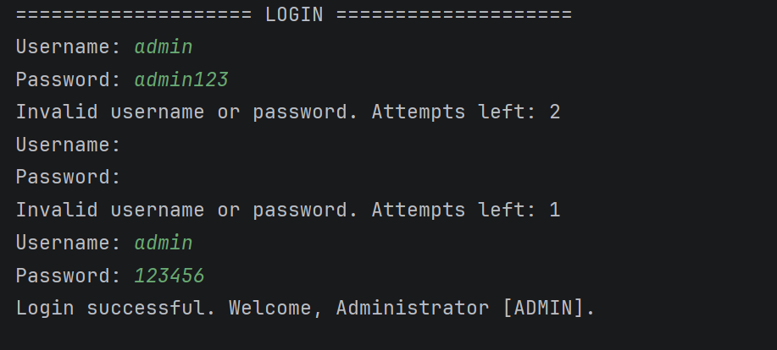
(Please insert image: Screenshot of the LOGIN screen)

10.4.2. Acceptable (updated)
Pattern | Explanation
USERNAME_VALID | 3–20 characters consisting of letters, digits, or underscore
PASSWORD_VALID | 6–20 characters, no whitespace

10.5. Permission Matrix (Role × Permission)
The table below summarizes the permissions of each role (Yes = allowed, No = not allowed):
Function | ADMIN | STAFF | VIEWER
New Registration | Yes | Yes | No
Update Registration | Yes | Yes | No
View / Search / Filter | Yes | Yes | Yes
Delete Registration | Yes | No | No
Statistics | Yes | Yes | Yes
Save Data | Yes | Yes | No
Volunteer Management | Yes | Yes | No
Account Management | Yes | No | No

10.6. Default Accounts
On the first run (when accounts.dat does not yet exist), the system creates 3 default accounts to demonstrate authorization:
Username | Password | Role
admin | 123456 | ADMIN
staff | 123456 | STAFF
viewer | 123456 | VIEWER

10.7. Authorization Feature Demonstrations

10.7.1. Login
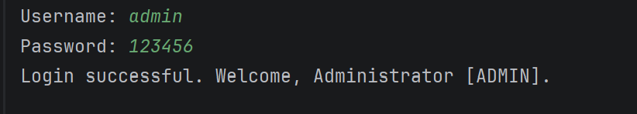
(Please insert image: Screenshot of a successful login with the admin account)
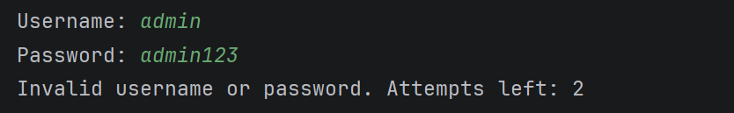
(Please insert image: Screenshot of a wrong password – showing the remaining attempts)

10.8. Conclusion of the Authorization Extension
The authorization extension has achieved:
- Applied standard RBAC: clearly separating Permission – Role – Account, making it easy to add new roles/permissions without modifying existing logic (Open/Closed Principle).
- Encapsulation: the password is hidden, and authentication and permission checks are handled by the object itself.
- Inheritance & Polymorphism: Account inherits from Person and overrides getDisplayInfo().
- Cleaner code: the MenuItem-based menu engine eliminates the long switch-case while automatically hiding functions the user is not authorized to use.
After adding authorization, the project has a total of 18 class/enum/interface files with approximately 1,844 lines of code.

--- End of Report ---

